**Case 1: Energy Forecasting**

**Flowchart :**

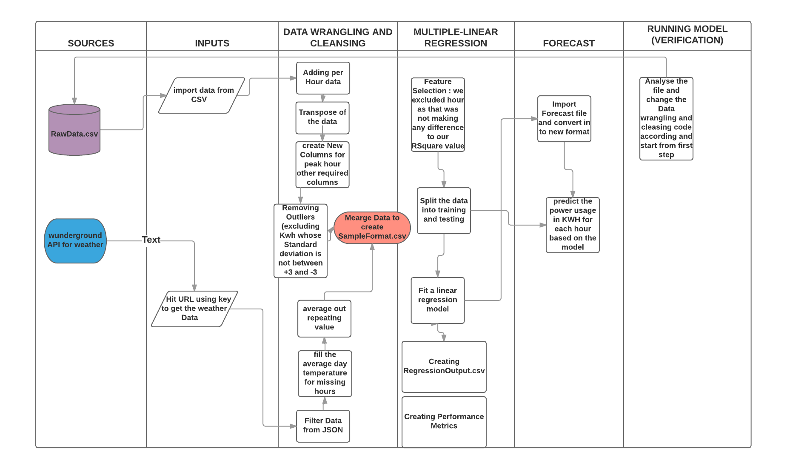

**Regression model design**

Algorithm

1. To find out the sum of Energy consumed for each hour of the day

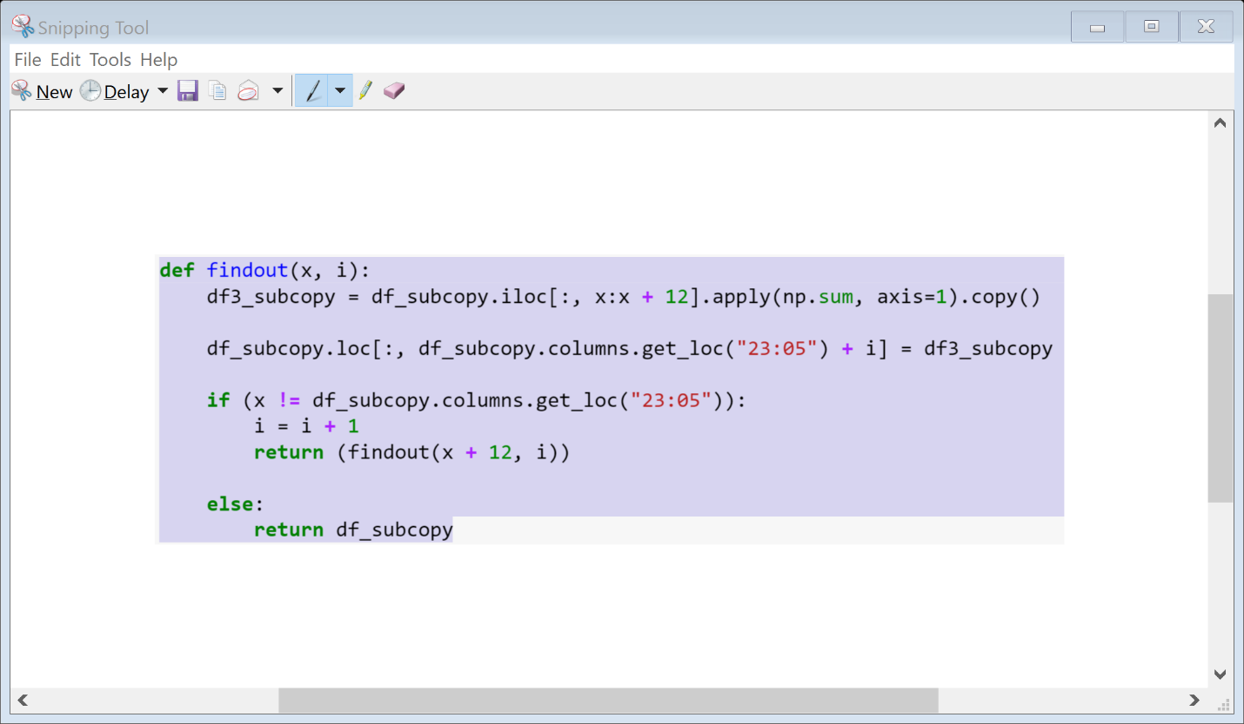

1. Finding temperature for each hour of the day

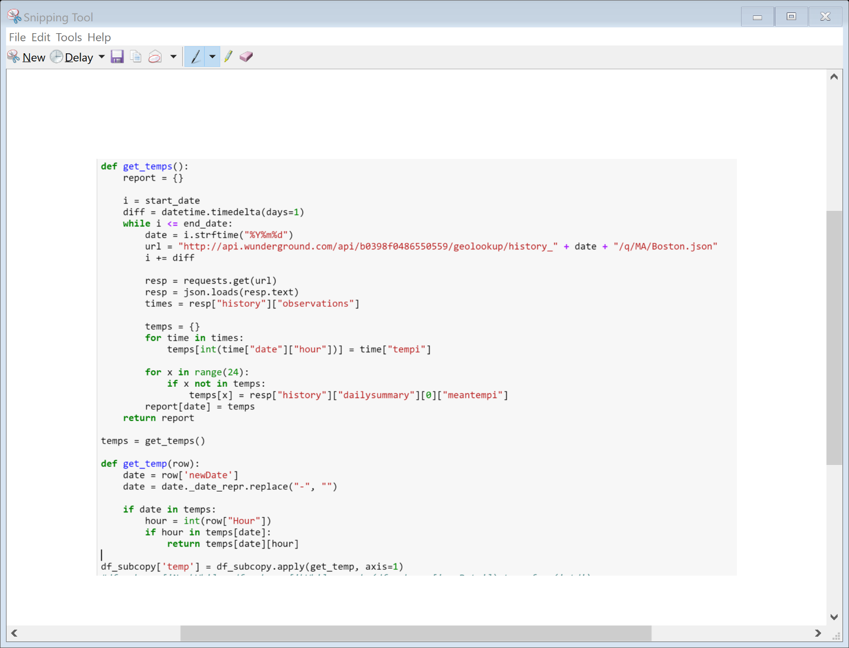

Regression Output

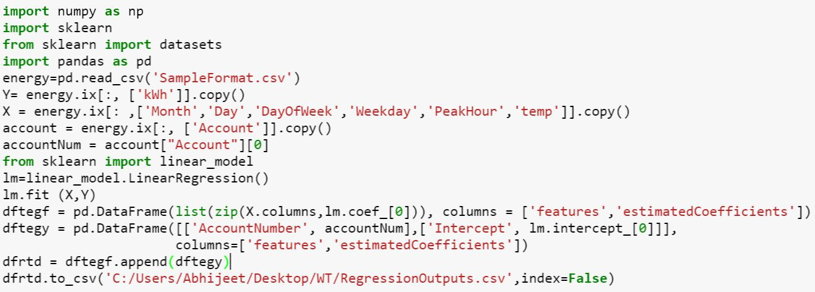

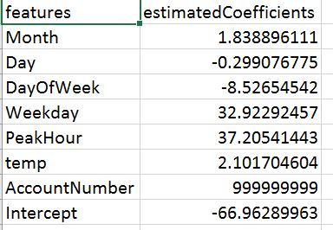

Performance Matrics

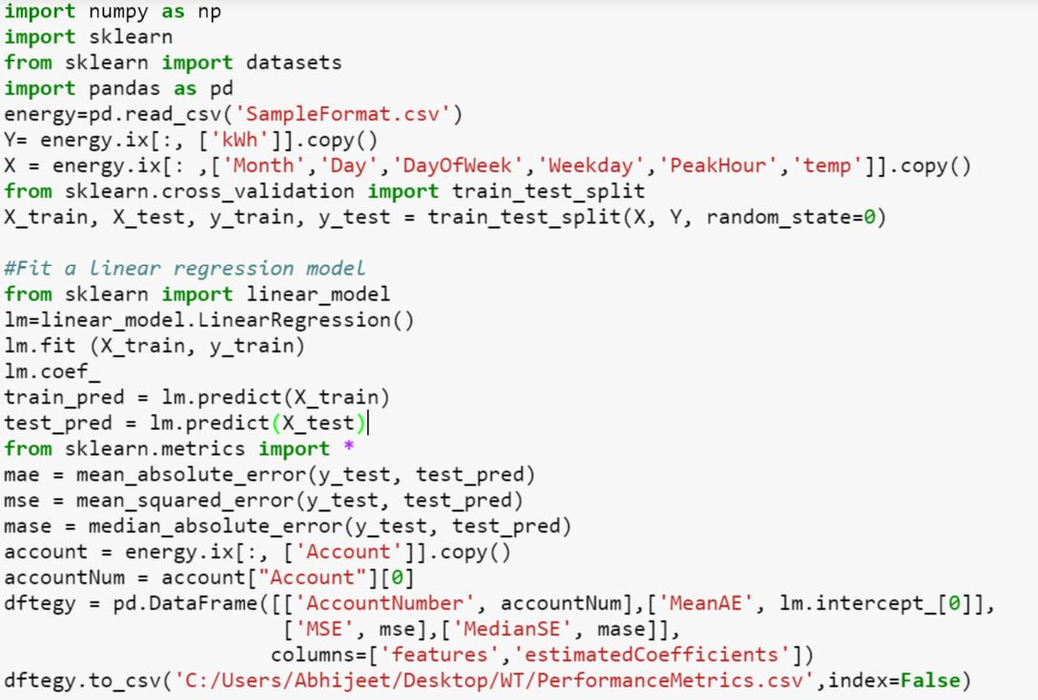

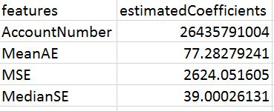

**Comments/Observations on model evaluation**

Upon analyzing t values and p-values and trying various permutations and combinations, we made the following observations:

(aWeekday, PeakHour and DayOfWeek contributed significantly/ had more weightage as the value of R-squared change significantly upon removing/adding these variables